

Q-Learning Management System
User manual

How to add a new Training Tittle
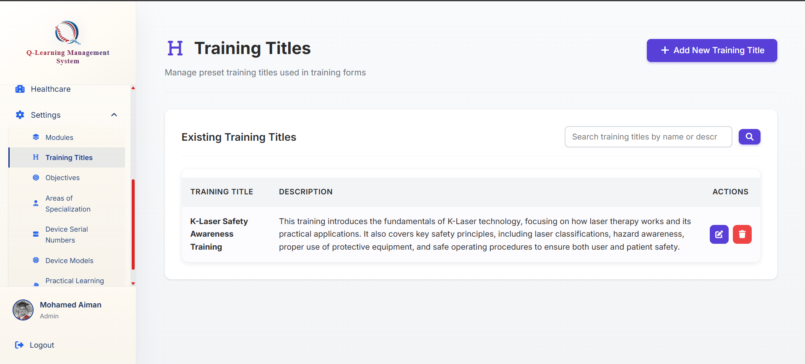
Click on the add Training tittle button

Go ahead to the Training title tab at the bottom of the sidebar
These titles would be used by the system when creating the training to save time later as well as reduce work and human error



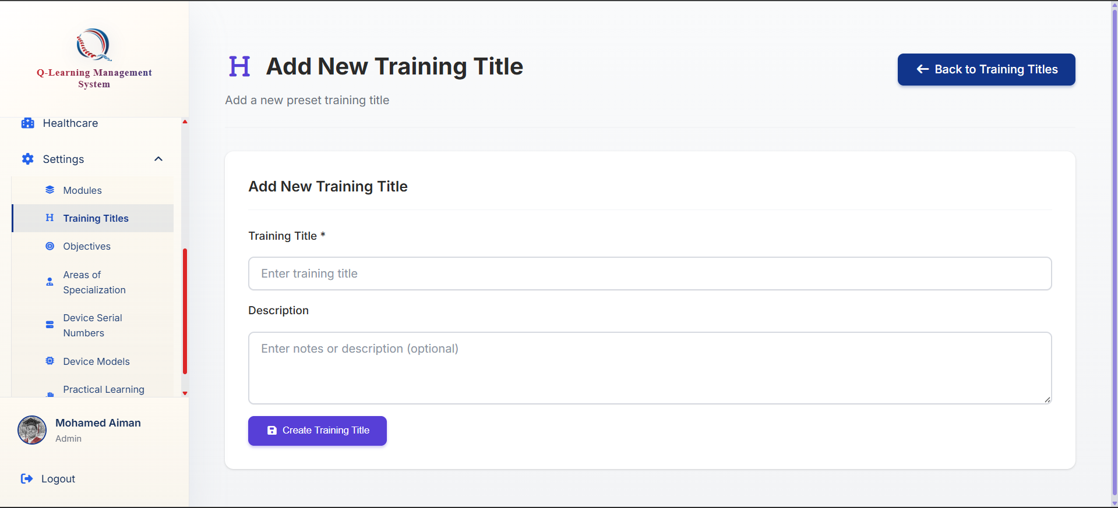
Click on this button to submit and create
You will be brought to this form where you may fill up the details needed

